  Lilac festival
  mackinac island
  june 12 – 17, 2020
  FRIDAY - WEDNESDAY
  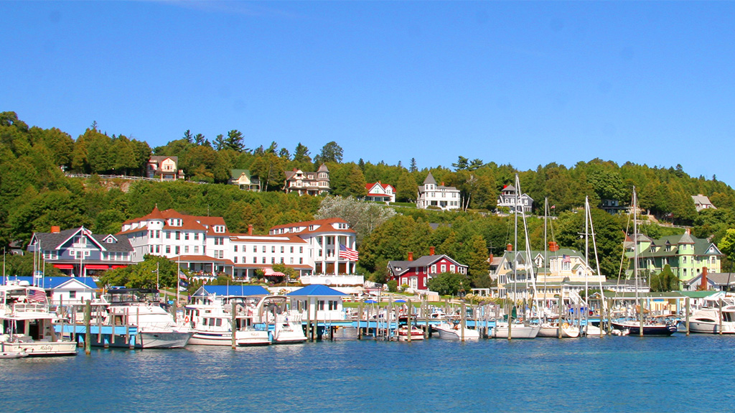
  Join the Judy’s Leisure Tours as we travel to Mackinac Island where a unique 19th Century atmosphere awaits us. Enjoy the sights and sounds of their Lilac Festival while staying on the Island.
  $1,475 Based on Double Occupancy
  Single Supplement Add $545
  - Baggage Handling
  - Tour Director
  - Motorcoach
  - Mackinaw City Sunset Trolley Tour
  - Mackinac Island Carriage Tour
  - Lunch at the Grand Hotel on Mackinac Island
  - Lilac Festival Grand Parade
  - Sleeping Bear Dunes National Lakeshore
  - SS Badger
  - Cabin Ridge Ride w/Dinner
  - Cook-Rutledge Mansion
  - 5 Breakfasts, 1 Lunch, 2 Dinners
  Lilac festival grand parade
  Carriage Tour of Mackinac ISland
  Sleeping Bear Dunes National Lakeshore
  T
  Cabin Ridge Rides
  For Reservations Contact:
  Judy’s Leisure Tours
  4906 Co Rd 31
  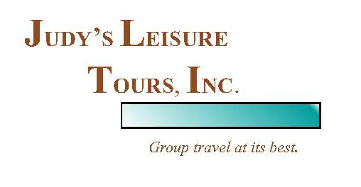
  Fargo, ND 58102
  (701) 232-3441
  www.judysleisuretoursinc.com

Day 1, Friday, June 12: We travel across Minnesota and Michigan as we begin our journey to Mackinac Island, Natives called it Michilimackinac or “Great Turtle”. We find our lodging in Michigan this evening.

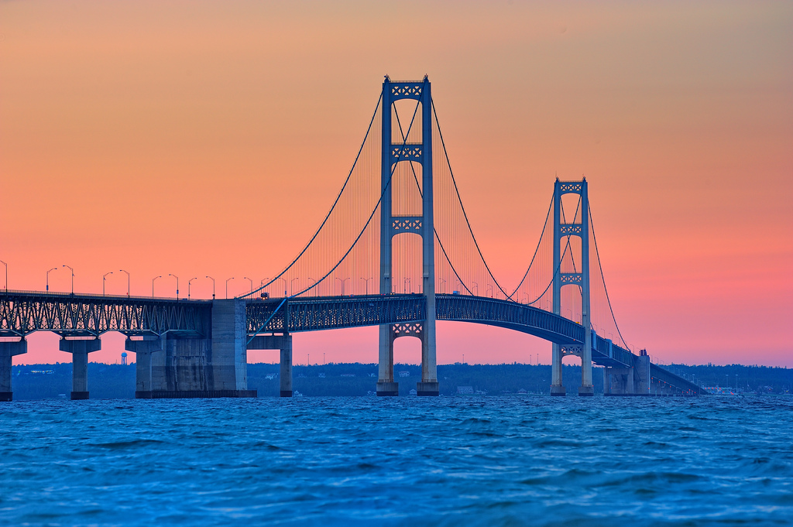
Day 2, Saturday, June 13: We travel to Mackinaw City. Lakes Superior, Michigan and Huron border the Upper Peninsula on three sides. Michigan’s two peninsulas are joined by the Mackinac Bridge, the world’s longest suspension bridge, providing a gateway to the Upper Peninsula. We arrive in Mackinaw City, check into our hotel. We will have an included BBQ Dinner this evening, and a Sunset Trolley Tour.

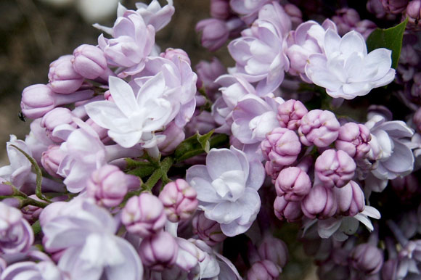
Day 3, Sunday, June 14: This morning, we board Shepler’s Ferry for our transport to charming Mackinac Island. Since motor vehicles are not permitted to intrude on the natural beauty of Mackinac Island, there is no better way to visit this historic isle and see the legendary points of interest than by carriage. You will visit areas that you may not discover on a bicycle or on foot. Our Carriage Tour will be expertly narrated, and we will travel in comfortable charming carriages “with the fringe on top.” We will enjoy the famous Grand Luncheon Buffet at the Grand Hotel, the crown jewel of Mackinac Island, and the world’s largest summer hotel since 1887. The idea of having a Lilac Festival was developed to bring people to the Island to enjoy a great horse drawn parade amidst the lovely lilacs that fragrance the Island in June. We are here to enjoy the Lilac Festival Grand Parade, considered a local legacy. You can watch the parade from our hotel lawn or various spots along the route. You have time to explore the quaint shops and purchase some of their famous fudge. We find our lodging on the island at Harbor View Inn.

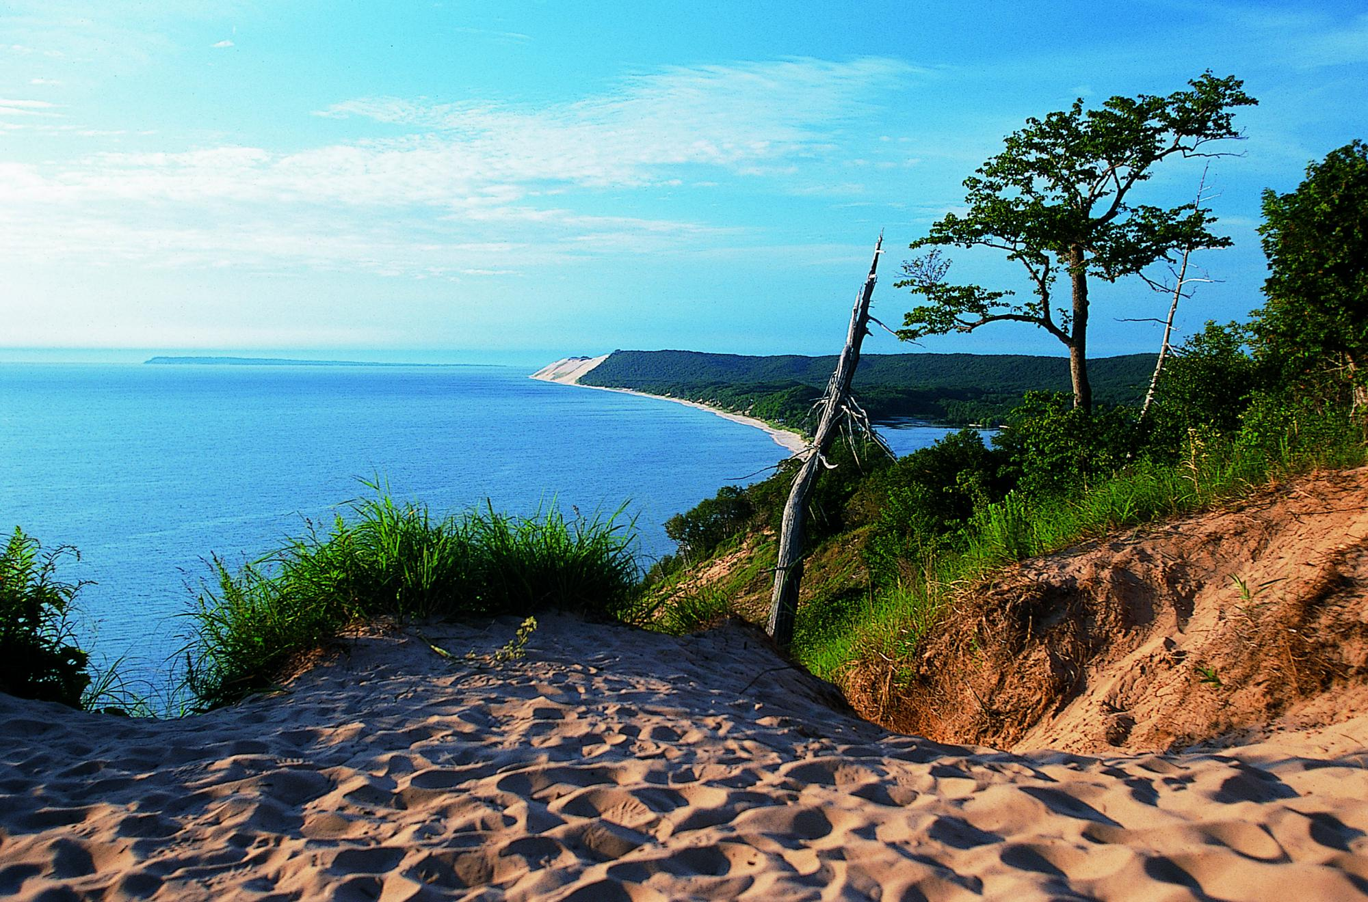
Day 4, Monday, June 15: We depart the beautiful island as we ferry across Lake Huron to our awaiting motorcoach. Next we are off to the Sleeping Bear Dunes National Lakeshore, tucked away in the northwest corner of Michigan’s Lower Peninsula. This area won the title of “Good Morning America’s” Most Beautiful Place in America. We will make stops to view the spectacular scenery and walk on the sandy shore. This evening we find our lodging in Ludington.

Day 5, Tuesday, June 16: We board the S.S. Badger for a relaxing 4-hour trip to Mianitowac. There is plenty to see and do aboard the huge ship. You can grab some lunch while on the ferry before our arrival in Mianitowac. We then make our way to Chippewa Falls, where we will have a delightful evening with Cabin Ridge Rides which includes a wagon ride through the woods to their Cabin Ridge where we will have a wonderful Dinner. We take the wagon back to our motorcoach and proceed to the hotel for our overnight in Chippewa Falls.

Day 6, Wednesday, June 17: Today we will have a relaxed morning before we start our day. Experience the grand lifestyle of the lumber era with a guided tour of the Cook-Rutledge Mansion. This 1887 restored and furnished lumber baron’s home is truly unique. The Mansion is one of the finest remaining examples of High Victorian Italianate Architecture in Wisconsin. As we make our way through the rolling hills of Wisconsin and the rich farmland of Minnesota, we reminisce about our wonderful experiences. The memories of our trip will stay with us for years to come.

Tour Cost

$1,475 Double
$1,445 Triple
$1,415 Quad
$2,020 Single

A $100 deposit will reserve your seat.
Final payment is due 30 days prior.

CALL TODAY TO REGISTER!

Judy’s Leisure Tours
(701) 232-3441 or (800) 598-0851

