- OCTOBER theatre  - October 19-20, 2019  - Featuring “RIPCORD” at the sidekick theater and “THE LOONEY LUTHERANS in Young(ish) at heart” AT ames center.  Join Judy’s Leisure Tours as we travel to Minneapolis for a theater get-away. We have lots to look forward to: food, laughter and two wonderful performances.  $375.00 Based on Double Occupancy  Single Supplement Add $ 68  - Quality Accommodations  - Motorcoach  - Baggage Handling  - Tour Director  - Sidekick Theatre  - Ripcord  - Ames Center  - The Looney Lutherans”  - Breakfast/Lunch/Dinner |  | RIPCORD  THE LOONEY LUTHERANS  breakfast, lunch & dinner included  T  FUn & Laughter  For Reservations Contact:  Judy’s Leisure Tours  4906 16th St N  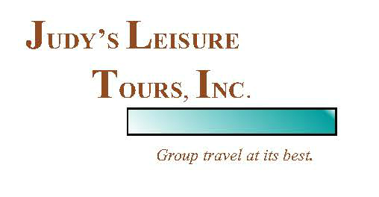  Fargo, ND 58102  701-232-3441  www.judysleisuretoursinc.com

Day 1, Saturday, Oct 19: Traveling down I-94 with our traveling companions we will stop en-route for you to have lunch before we arrive in the twin cities for our overnight lodging at Hampton Inn -Burnsville. You will have time to relax and freshen up before we head over to our performance this evening.

We have reserved seats at the Sidekick Theatre where we will enjoy a delicious dinner from their menu and see the comedy RIPCORD”. When cantankerous Abby is forced to share her room in assisted living with endlessly chipper Marilyn, the two women make a seemingly harmless bet that quickly escalates into a hilarious game of practical jokes and one-upmanship, revealing hidden truths that neither wants exposed.

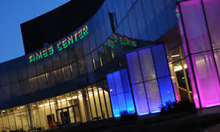
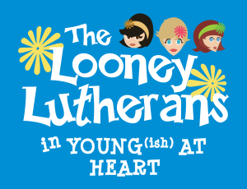
Day 2, Sunday, Oct 20: This morning we will enjoy an included breakfast at our hotel. We make our way to the Ames Center where we will have an included lunch before the performance. We will be entertained by “The Looney Lutherans in Young(ish) At Heart.” The Looney Lutherans are a trio of wacky gals who use music, comedy, and help from the audience to share their tips for aging humorously in YOUNG(ish) AT HEART. This interactive comedy event included the game show What’s in Your Lunchbox? (hosted by your favorite luncheon meat): musical advice for dealing with those aches and pains; and creative tips for keeping fit, because Jello isn’t the only thing that jiggles.

After an uplifting afternoon at the theatre it is now time to head for home. We share with friends our thoughts of Fall and the great performances and laughter we have shared in the Twin Cities. We will make the normal stops in route for comfort as we travel home.
Tour Cost
$375.00 Double
$365.00 Triple
$355.00 Quad
$443.00 Single

A $100 deposit will reserve your seat.
Final payment is due 30 days prior.
CALL TODAY TO REGISTER
Judy’s Leisure Tours
701/232-3441 or 800/598-0851

